Overview of Harrow’s population and changes

Harrow’s main sources of population data are the Office for National Statistics (ONS) and the Greater London Authority (GLA).
The ONS produce the National Census every decade, the Mid-Year Estimates (MYE) annually and the Sub-National Population Projections (SNPP) approximately every two years; these datasets include births and migration data.
The GLA Demography Team produce a range of annually updated population projections at both borough and ward level for the 33 local authorities in the London region. The GLA’s Borough Preferred Option (BPO) round of projections are produced for London boroughs based on development data or the latest GLA ward level Strategic Housing Land Availability Assessment (SHLAA).

Harrow uses the GLA’s Borough Preferred Option based on Harrow’s latest available housing trajectory, and they use this BPO to produce our School Roll Projections on.

The 2021 BPO are available for three scenarios.

5-year constrained - This projection is based on 5 years of past local migration patterns and constrained to match the 5-year trend projection results at subregional (NUTS2) level. Migration trends during this period (mid-2016 to mid-2021) were dominated by the effects of Brexit and the COVID-19 pandemic and this projection represents a pessimistic scenario of future population growth in London.
15-year constrained – This projection is based on 10 years of past local migration patterns and constrained to match the 15-year trend projection results at subregional (NUTS2) level. The 15-year period (mid-2006 to mid-2021) includes a decade of high population growth in London which offsets the subsequent years of lower growth in the trends projected forward. This is the most optimistic scenario of the 2021-based outputs, but still shows lower growth than previous rounds of projections.
10-year constrained – This projection is based on 10 years of past local migration patterns and constrained to match the 10-year trend projection results at subregional (NUTS2) level. The period (mid-2011 to mid-2021) used to determine future migration trends covers five years of high levels of population growth in London and five years of low growth impacted by Brexit and the pandemic. The results typically lie between those of the 5-year and 15-year projections.

Based on the recommendation of Harrow’s Demography Team we have used the School Roll Projections based on the Scenario 2 BPO.

ONS 2021 National Census – First Release

On 28 June 2022 ONS released the first results from the 2021 Census of England and Wales comprising for each local authority the estimated population at census day (21 March 2021), the number of households and population density. Population estimates are by five-year age band and sex. Estimates of responses rates for each local authority were also published.

Data in the 2021 census first release are rounded to the nearest 100. Future releases will provide unit-level estimates. Estimates of Londoners’ characteristics including for small areas will be published from October 2022 onwards.

Census Population

- England’s population grew by 3.5 million (6.6% increase since 2011) to 56,489,800 million.
- London grew by 626 thousand persons (7.6 percent) to 8.8 million in the decade since the last census.
- London’s growth rate over the decade was higher than the national average (6.3 percent) but lower than that of East of England and the South West regions.

The change in population is due to – Births, deaths, internal and international migration. From April 2011 to end of March 2021 there have been:

- 6.8 million live births
- 5.3 million = deaths
- Resulting in a natural increase = 1.5 million
- The remainder change due is to positive net migration

- Harrow’s population increased to 261,300 by 9.3% since the 2011 Census – see table and map below.

Borough | 2011 Census | 2021 Census | Change 2011-2021 | Percentage change
Harrow | 239,100 | 261,300 | 22,200 | 9.3%

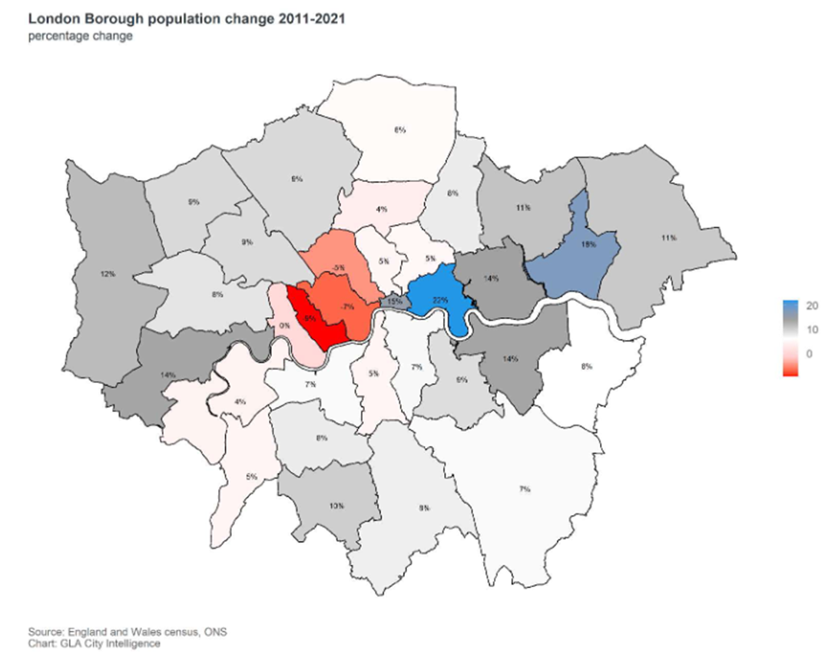

Census Households

- England’s number of households increased by 6.1% (1.4 million).
- There are a total of 3.42 million households in London, an increase of 158 thousand (4.6 percent) since the 2011 census. This data does not include empty dwellings so if a proportion of homes were vacant when the census was taken then these would not show in this data.
- Harrow’s number of households increased to 89,600 in 2021, an increase of 6.3% from 84,268 in 2011.

Census Age Groups

Population growth over the decade is concentrated in older ages. There were fewer 0-to-4 year-olds and 20-to-29 year-olds in 2021 than in 2011.

- Two-thirds of England’s population (64.1%) are between 15 and 64 years old, 17.4% (10.4 million) are under 15.
- There are less 4 and under, 15 to 19 year olds and 20 to 24 in 2021 than there was in 2011, with only an increase in the number of 5 to 9 year olds over the last decade.
- London’s population is much younger than the rest of the country, 18.1% of it’s population is under 15 years old.
- Harrow’s population is made up of 18.5% of under 15 years, 66.2% of 15 to 64 year olds and 15.4% of 65 & above years. As can be seen in the table and chart below.

Area name | Aged 4 years and under |  | Aged 5 to 9 years |  | Aged 10 to 14 years |  | Aged 15 to 19 years |  | Aged 20 to 24 years
 | # | % | # | % | # | % | # | % | # | %
Harrow | 15,700 | 6.0% | 16,100 | 6.2% | 16,500 | 6.3% | 15,100 | 5.8% | 15,100 | 5.8%
London | 529,000 | 6.0% | 531,500 | 6.0% | 535,400 | 6.1% | 489,400 | 5.6% | 589,200 | 6.7%
England | 3,077,000 | 5.4% | 3,348,600 | 5.9% | 3,413,100 | 6.0% | 3,218,900 | 5.7% | 3,414,400 | 6.0%

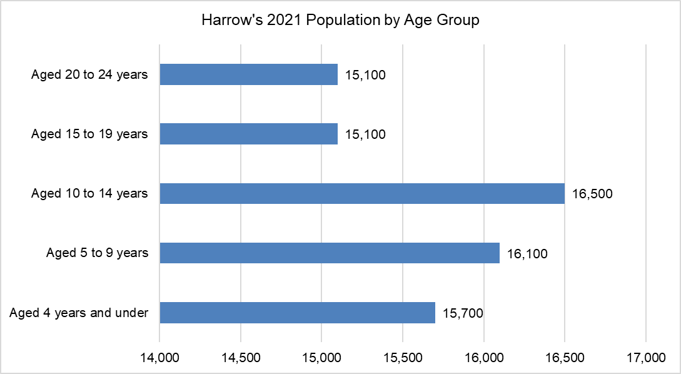

Economic migrants from within the UK and from overseas in their 20s and 30s give London its distinctive age structure. The older population is comparatively much smaller in London as people migrate away from the capital as they begin to form families and then later again as they move into retirement.

ONS Population Projections and Estimates
Population Estimates (MYE) are the official source of estimated population size in between the censuses and inform a wide range of national statistics.
Population Projections (SNPP) provide statistics on potential future size and age structure of the population. They are based on past trends and assumptions of future levels of births, deaths and migration. They do not incorporate local development plans but instead provide a baseline, which can be combined with local knowledge.
The ONS’s SNPP project what the population of every local authority will look like over the next 25 years. It should be noted that all population projections become increasingly uncertain the further they are carried forward due to the inherent uncertainty of demographic behaviour.
The 2018-based SNPPs take the 2018 Mid-Year Estimates (MYEs) as their starting point, then: the population is projected forward a year at a time to 2041; the population is aged on from the previous year; the projected number of births and deaths are added; and adjustments for net migration are included. Births, deaths and migration are based on the trends observed in each local authority over the period mid-2011 to 2014. Finally the SNPPs are constrained to be consistent with the national projections for England.
GLA Borough Preferred Option Results for Harrow

Population Change
The population of Harrow is estimated to have grown by 20,321 persons (8.4 percent) between
2011 and 2021. Over the next decade from 2022 to 2032 the population is projected to grow by 17,581 persons (6.6 percent). By 2041 the population is projected to reach 292,300 persons, a 18.3 percent increase on the 2011 population.

Table 14 below outlines the total population of Harrow from the census base population of 240,499 through five-year intervals to a projected 2041 population of 280,336.

Table 14: Population of Harrow
Year | 2021 Population
2011 | 240,499
2016 | 255,404
2021 | 260,820
2026 | 274,071
2031 | 282,358
2036 | 286,453
2041 | 292,300
Source: 10-year constrained

Age structure
The greatest growth in Harrow, between 2011 and 2021 and 2011 and 2031, is projected to be in the 65 and over age group, as can be seen in the table below.

Table 15: Age structure of Harrow - 2021
Age Group | Population 2011 | Population 2021 | Percentage Change (2011 to 2021) | Population 2031 | Percentage Change (2011 to 2031)
0 to 3 | 12,885 | 12,396 | -3.8% | 13,472 | 4.6%
4 to 10 | 20,398 | 22,557 | 10.6% | 20,846 | 2.2%
11 to 15 | 14,892 | 16,357 | 9.8% | 15,677 | 5.3%
16 to 25 | 31,905 | 30,636 | -4.0% | 33,180 | 4.0%
26 to 64 | 126,533 | 138,412 | 9.4% | 148,845 | 17.6%
65 and over | 33,886 | 40,462 | 19.4% | 50,334 | 48.5%
Source: 10-year constrained

ONS 2022 Mid Year Estimates (MYE)

Please note that the ONS have revised their MYE back to 2012. Therefore the tables and charts below have been updated to include the most recent data released.

Harrow’s population
Harrow’s population has increased from 240,499 in 2011 to 261,185 in 2022, increasing by 26 from 2021 to 2022.

Harrow | mid-2011 | mid-2012 | mid-2013 | mid-2014 | mid-2015 | mid-2016 | mid-2017 | mid-2018 | mid-2019 | mid-2020
Population | 240,499 | 243,800 | 247,018 | 251,618 | 255,308 | 257,317 | 257,881 | 259,861 | 262,065 | 262,281

Harrow | mid-2021 | mid-2022
Population | 261,159 | 261,185
Source: Analysis of Population Estimates Tool

Harrow’s population from mid-2011 to mid-2022
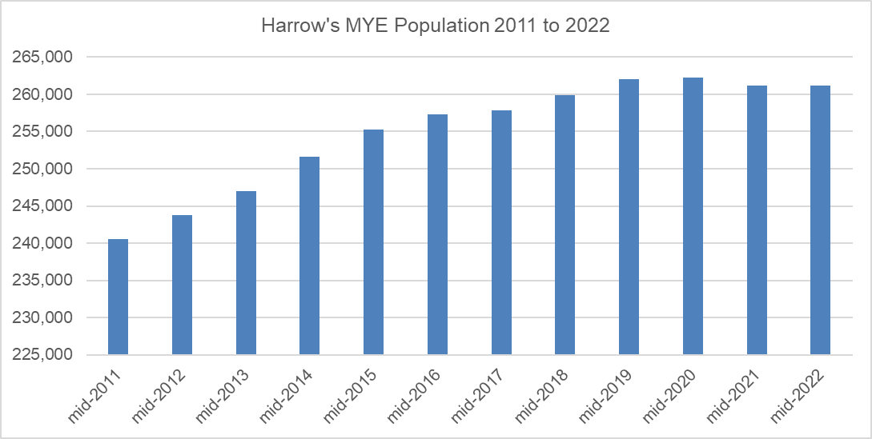 Source: Analysis of Population Estimates Tool

Harrow’s population increase between 2021 and 2022 (26) is lower than it’s neighbouring London boroughs; Barnet increased by 146, Brent increased by 1,973, Ealing increased by 3,175 and Hillingdon by 5,574.

Harrow’s births
As can be seen in the table and chart below Harrow’s births based on the ONS’s MYE have fluctuated between 2012 and 2022. Harrow’s births peaked at 3,661 in mid-2016, and increased again in mid-2018 to 3,655. However births continued to drop until mid-2021, falling from 3,543 in mid-2019 to 3,317 in mid-2021 but increased very slightly to 3,329 in mid-2022.

MYE | Births
mid-2012 | 3,530
mid-2013 | 3,620
mid-2014 | 3,574
mid-2015 | 3,509
mid-2016 | 3,661
mid-2017 | 3,624
mid-2018 | 3,655
mid-2019 | 3,543
mid-2020 | 3,505
mid-2021 | 3,317
mid-2022 | 3,329
Source: Analysis of Population Estimates Tool

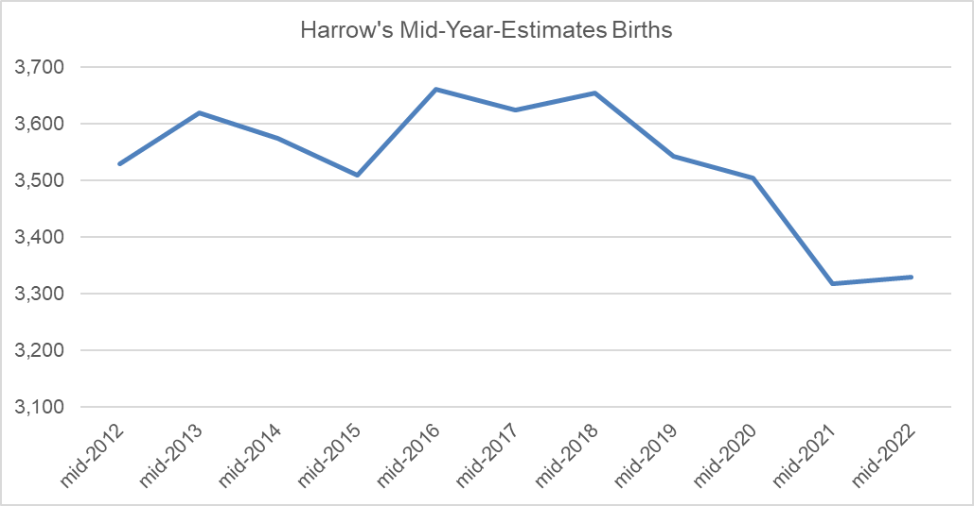
Source: Analysis of Population Estimates Tool

Harrow’s migration
As can be seen in the table below Harrow’s internal migration resulted in a net loss of 2.5k people in 2020, net loss of 4.9k in 2021 and net loss of 4.8k in 2022. International migration resulted in a net gain of 686 people in 2020, net gain of 2k in 2021 and net gain of 3.2k in 2022. Net impact of total migration was a 1.9k loss in 2020, 3k loss in 2021 and 1.5k loss in 2022.

Harrow | 2020-MYE | 2021-MYE | 2022-MYE | Diff  2021-2022 | Direction
Internal inflow | 17,463 | 19,188 | 18,291 | -897 | Loss
Internal outflow | 20,058 | 24,162 | 23,134 | -1,028 | Loss
Internal net diff | -2,595 | -4,974 | -4,843 | 131 | Loss
International inflow | 5,943 | 6,620 | 8,399 | 1,779 | Gain
International outflow | 5,257 | 4,624 | 5,116 | 492 | Gain
International net diff | 686 | 1,996 | 3,283 | 1,287 | Gain
Overall net diff | -1,909 | -2,978 | -1,560 | - | Decreased loss
Source: Analysis of Population Estimates Tool

ONS 2018-based Subnational Population Projections (SNPP)

Published on 24th March 2020, the SNPP suggest that the populations of all regions within England are projected to grow by mid-2028. All regions are projected to have a greater proportion of people aged 65 and over by mid-2028. London is still the largest growing region but no longer the fastest growing as it was in the 2016 SNNPs, it has dropped to 5th place in 2018.

Local Authorities

Population projections at local authority level are especially subject to annual local fluctuations in source data. Also, the actual local population change will be influenced by local economic development and housing policies.

Nearly all local authorities are projected to grow by mid-2028. Of the LAs with the highest projected population growth from 2018 to 2028 the only London borough is Tower Hamlets. Of the LAs with the highest projected population decline from 2018 to 2028 the only London borough is Ealing.
Harrow’s 2018-based SNPPs

Harrow’s population
The table below shows Harrow’s population over the next 10 years – it shows there is a very slow and steady increase from 2018 to 2028.

Year | Harrow Population
2018 | 250,149
2019 | 250,419
2020 | 250,751
2021 | 251,095
2022 | 251,350
2023 | 251,462
2024 | 251,467
2025 | 251,389
2026 | 251,371
2027 | 251,313
2028 | 251,337

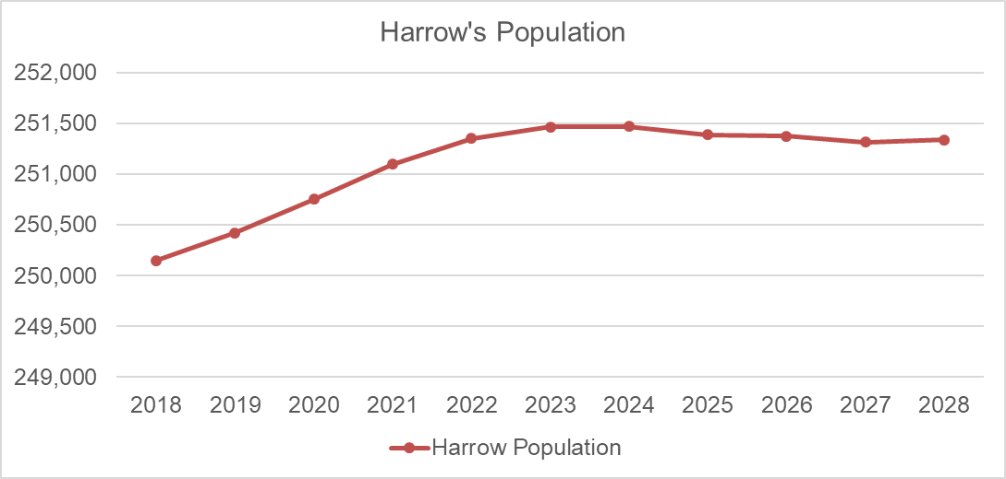

Harrow’s births
Harrow’s births are projected to fall from 3,260 in 2019 to 3,116 in 2023 and 2,970 in 2028.

Births | Harrow
2019 | 3,260
2020 | 3,248
2021 | 3,214
2022 | 3,167
2023 | 3,116
2024 | 3,048
2025 | 3,029
2026 | 3,009
2027 | 2,988
2028 | 2,970

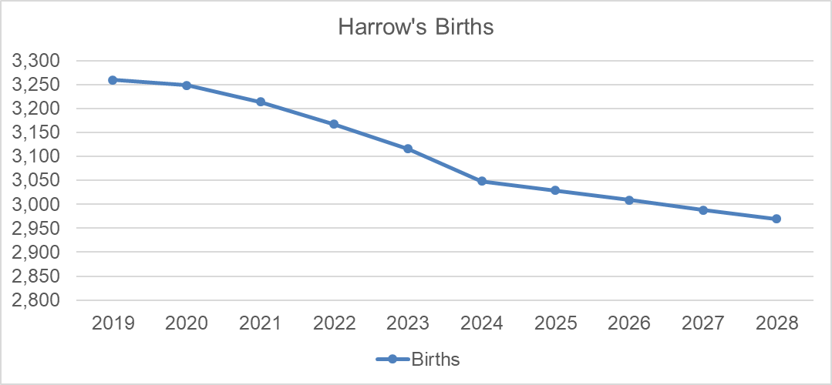

Harrow’s age ranges
The table below shows Harrow’s age ranges up to 90+. There is a projected drop in the 0 to 9 and 20 to 39 age ranges, with an increase for the remainder of the ages.

AGE GROUP | 2018 | 2021 | 2024
0-4 | 17,745 | 16,603 | 15,518
5-9 | 16,783 | 17,267 | 16,560
10-14 | 15,080 | 15,729 | 16,579
15-19 | 13,767 | 13,553 | 14,188
20-24 | 13,528 | 12,561 | 11,656
25-29 | 17,457 | 16,857 | 16,635
30-34 | 19,119 | 18,214 | 17,132
35-39 | 19,467 | 18,657 | 17,880
40-44 | 17,210 | 18,266 | 18,254
45-49 | 16,432 | 16,404 | 16,993
50-54 | 15,926 | 15,865 | 15,808
55-59 | 15,278 | 15,520 | 15,424
60-64 | 13,155 | 13,874 | 14,609
65-69 | 11,190 | 11,924 | 12,689
70-74 | 9,598 | 10,148 | 10,314
75-79 | 6,996 | 7,637 | 8,577
80-84 | 5,740 | 5,737 | 5,878
85-89 | 3,530 | 3,881 | 4,110
90+ | 2,148 | 2,400 | 2,663
All ages | 250,149 | 251,095 | 251,467

Migration
Harrow’s internal migration net loss of people has continued to drop over the last 4 years, as can be seen in the table below.

Harrow | 2016 MYE | 2017 MYE | 2018 MYE | 2019 MYE
Internal migration Net | -4,988 | -4,036 | -3,458 | -2,138

In contrast, International migration has resulted in a net gain, which has been dropping over the last few years, as can be seen in the table below.

Harrow | 2016 MYE | 2017 MYE | 2018 MYE | 2019 MYE
International migration Net | 3,035 | 3,202 | 2,390 | 1,718

The net impact of total migration in Harrow over the last four years has resulted in a loss of people, as can be seen in the table below.

Harrow | 2016 MYE | 2017 MYE | 2018 MYE | 2019 MYE
International migration Net | -1,953 | -834 | -1,068 | -420

The SNPP project a relatively steady picture regarding Harrow’s internal and international migration from 2018 to 2028

Harrow | 2018 | 2028 | Difference 2018-2028
All migration net | -1,505 | -1,257 | 248
Internal migration in | 15,469 | 15,420 | -49
Internal migration out | 19,893 | 18,952 | -941
International migration in | 4,900 | 4,094 | -806
International migration out | 1,892 | 1,725 | -167
Cross border migration in | 244 | 237 | -7
Cross border migration out | 334 | 332 | -2

Migration by age
The ONS SNPPs contain migration projections by age. Harrow’s net internal migration is overall projecting a loss of children of the following age ranges 0 to 4, 5 to 9, 10 to 14 and 15 to 19. There is projected gain for young people of the age range 20 to 24.

Internal net | 2019 | 2023 | 2028 | Direction
0-4 | -367 | -310 | -270 | Decreasing loss
5-9 | -367 | -383 | -332 | Decreasing loss
10-14 | -86 | -89 | -103 | Increasing loss
15-19 | -1,556 | -1,555 | -1,628 | Increasing loss
20-24 | 611 | 930 | 1,078 | Increasing gain

Harrow’s net international migration projects an increasing number of children migrating into Harrow for all the age ranges, however the increase is declining from 2019 to 2028.

International net | 2019 | 2023 | 2028 | Direction
0-4 | 294 | 260 | 243 | Decreasing gain
5-9 | 193 | 171 | 159 | Decreasing gain
10-14 | 171 | 151 | 141 | Decreasing gain
15-19 | 263 | 231 | 215 | Decreasing gain
20-24 | 484 | 408 | 368 | Decreasing gain

Overall net migration – there is a projected loss from 2019 to 2028 of the age ranges 0 to 4 and 5 to 9 and 15 to 19; and a projected gain of the age ranges 10 to 14 and 20 to 24.

Net Migration | 2019 | 2023 | 2028 | Direction
0-4 | -73 | -50 | -27 | Decreasing loss
5-9 | -174 | -212 | -173 | Stable loss
10-14 | 85 | 62 | 38 | Decreasing gain
15-19 | -1,293 | -1,324 | -1,413 | Increasing loss
20-24 | 1,095 | 1,338 | 1,446 | Increasing gain

It should be noted that these projections are purely based on past trends, so any impacts that Brexit or the Covid-19 pandemic may have on future migration levels (or as a result of any other changes in government policies or economic circumstances) are not considered.

